This assignment involves working out and learning fitness vocabulary! You need to get 100 points, so pick which options you want to do, write how many points you got in the boxes, and add up the points in the “total points” box! These exercises are designed to be done with dad (or another family member!), so ask him to work out with you and to sign anywhere that says “Dad’s signature” and get more points!

This part involves watching a workout video and doing the exercises (Option A) OR doing the exercises shown if you don’t have a computer at home (Option B)! Draw a check mark in the boxes by the exercises to show that you did them!

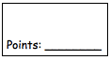
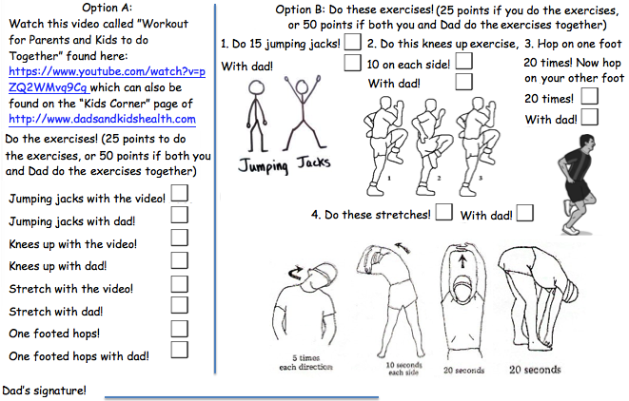
Part Two:
Write these words 5 times each! (25 points)

Stretch Cardio Core Twist Calves

Thighs Balance Exercise Fitness Workout

Put these words in alphabetical order: stretch, cardio, core, twist, calves, thighs, balance, exercise, fitness, workout! (25 points)
1. 2. 3. 4. 5.

6. 7. 8. 9. 10.

With Dad’s help, write a paragraph about what you liked about the video or the exercises! (3-5 sentences) (25 points)

Ask Dad what he liked about the video/exercises, and with his help write another paragraph! (3-5 sentences) (25 points)

Dad’s signature!

