Let’s work out and learn new fitness words! You need to get 10 points, so pick what you want to do, write the number of points you get in the boxes, and add up the points in the “total points” box. If you do some things with dad you’ll get more points, so ask him to work out with you and have him sign anywhere that says “Dad’s signature!”

For this part, watch a workout video and do the exercises (Option A)! Or, if you don’t have a computer at home, you can do the exercises in the pictures (Option B)! Draw a check mark in the boxes to the exercises to show that you did them!

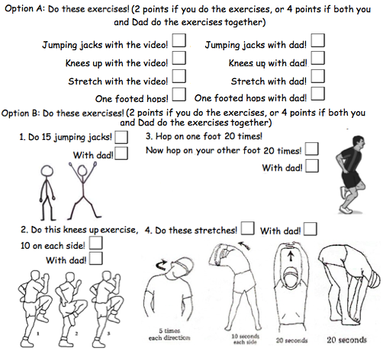

Dad’s signature!

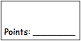

With Dad’s help, write a sentence about what your favorite part of the video or workout was! (2 points)

With Dad’s help, ask Dad what his favorite part of the video or workout was, and write it in a sentence! (2 points)

Draw a picture of you and Dad doing your favorite exercises! (2 points)
Write these words! (6 points for all the words!)

